FEEDBACK-

create table feedback

(

name varchar2(30),

email varchar2(30)primary key,

message varchar2(200),

);

insert into feedback values(riya,'riya@gmail.com','satisfies and got help on time');

insert into feedback values(ram,'ram@gmail.com','satisfies and got help on time');

insert into feedback values('shree','shree@gmail.com','satisfies and got help on time');

select * from feedback;

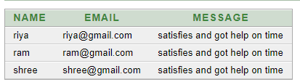

Desc feedback;

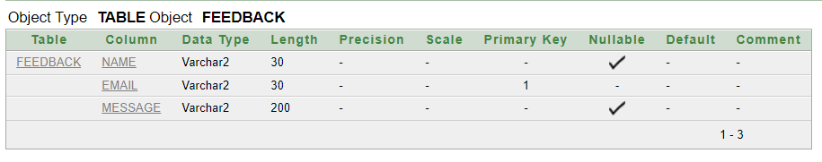

**Feedback Form**

|  |  |
| --- | --- |
| **Name** |  |
| **Email** |  |
| **Message** |  |

**Submit**

Medical Request-

create table medical

(

email varchar2(30)primary key,

address varchar2(40),

medicine varchar2(100)

);

insert into medical values('shree@gmail.com','bangalore','medicine1');

insert into medical values('ram@gmail.com','kr puram','medicine2');

insert into medical values('riya@gmail.com','yelahanka','medicine1');

select * from medical;

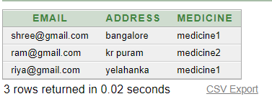

desc medical;

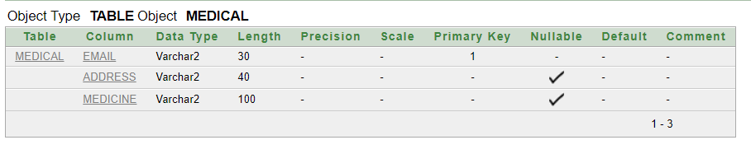

**Medical Form**

|  |  |
| --- | --- |
| **Email** |  |
| **Address** |  |
| **Medicine** |  |

**Submit**